
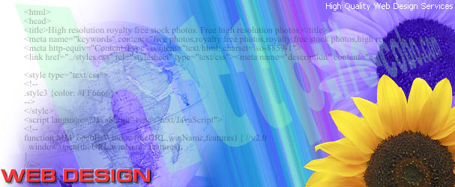

CRAIG WEB DESIGN
Craig Web Design is comprised of a team of specialists in web site design, search engine optimization, search engine ranking, web site marketing and website maintenance. We are more than a web design firm because we are committed to providing web site traffic.
Our rates are amazingly affordable…we will design a 10 - page site with 20 images and a wealth of features.
We design sites dedicated to driving traffic to your site. Creating directories and giving our clients prime positioning has a profound influence on our clients' ability to get traffic and make their projected sales goals.
Our websites include the following industries: fine art photography, party goods, entertainment, restaurants and catering. Please review our extensive portfolio and give us a call at 609-221-9959 to discuss how we can be of service to you.
Pricing and Process
Craig Web Design is a collection of several professional experts. They are from diverse professional backgrounds in graphic design, illustration, photography, e-commerce, programming, and web site development.
A complete basic site costs $499. When your site is up and running and to your satisfaction you will be billed monthly $24.99 or $34.99 whichever monthly program you choose. See below for further details.
This package includes:
• Design
• Programming
• Coding for search engines
• Server connection
• Domain name registration for 2 years
• Search Engine Submission (no additional cost)
• Introductory Splash Page + up to 9 pages
• 20 graphics
1) The cost for maintenance is $24.99 per month. (The fee includes monthly server costs plus revisions, additions and deletions to your site on a monthly basis for up to an hour of labor per quarter. The alternative is a $34.99 monthly maintenance fee with twelve hours of changes per year. (The fee includes monthly server costs.)
2) This package includes registration with the primary search engines at no additional cost. We construct your site to be "found" by those search engines and make revisions in your site's coding to be continually found by those search engines as part of the maintenance program.
3) This basic package comes with an introductory or splash page plus twenty graphics divided into a maximum of four categories. Additional graphic costs are $5.00 for each image over 20 in the basic package.
4) A deposit of 1/2 at the beginning, and 1/2 upon completion. When your site is up and running and to your satisfaction you will be billed monthly $24.99 or $34.99 whichever monthly program you choose.
5) We estimate your site will be ready 3-6 weeks after we receive graphics and copy. We like to drop our company logo and additional links at the bottom of your first page as a link to our own page. We create your site to be operational in all browsers.
6) Sites with shopping carts are more expensive than our basic package. The initial payment is $799.00. The monthly maintenance charge is $49.99 month.
7) Hourly Rate is $35.00/Hour for any additional services above the 10-page site with 20 images.

GETTING STARTED
There are four things that we need from you to create a site.
Your Domain Name - Your first decision is whether you use the name of your company as your domain name (the domain name is what follows the www) or if you use a word or words that summarize your service or product. If you will rely on advertising or promotion to bring in visitors, then using your company name makes the most sense. If you plan to bring in most new customers via search engines, then your primary service or product should be embedded in the domain. The domain name is one of the six criteria search engines check when they decide how high to rank you in a search. For some search engines it makes the difference between a high ranking and a low one. Please let us register your domain name. Transferring domain names is one of the most common challenges in our industry.
Your Categorization System - People have the shortest attention span when they are on the Internet. Making your message quick and easy to read is essential. This means your site has to load quickly. To make an immediate, clear impression means you have to categorize your service or product into easy-to-understand categories that will load quickly. We will guide you to not overwhelm any one category with too many graphics or words. We create your navigation system to directly reflect the categories you use to communicate your message.
Your Graphic Choices - For some clients, such as retailers, this is another challenging step. Picking 100 SKU's from an inventory of 3000 items from 400 vendors can take time. We work from photographs, disks, e-mailed jpgs, transparencies, or brochure material. Many of our web sites are created from vendor catalog sheets. Processing graphics is the most time-consuming step when creating most web sites. Our staff is Photoshop savvy. Tightening up contrast, cleaning up the color, deleting unrelated material, and dropping out backgrounds (to decrease loading time) often take fifteen minutes per graphic. For most sites, the number of graphics will determine the cost of your site.
Choosing Your Text - We do not charge for text if you transmit it to us electronically. We just lift it from a disk or e-mail and drop it into your site. If there are sizable amounts of italics, bolds, or unusual indentations, we charge our normal hourly rate for the additional coding. Most sites, aside from academic sites (lots of italics), do not incur any charges. Copy for the web should be short, clear, concise and easy to read.

